COAL LAB # 6

Exercise 1.1:

Code:
org 100h
MOV AL,01101111b
AND AL,00101101b
RET

Output:
AL = 2C or 00101101

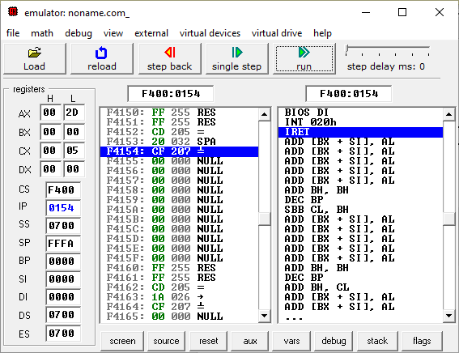

Exercise 1.2:

Code:
org 100h
MOV AL,6Dh
AND AL,4Ah
ret

Output:
AL = 48 or 01001000
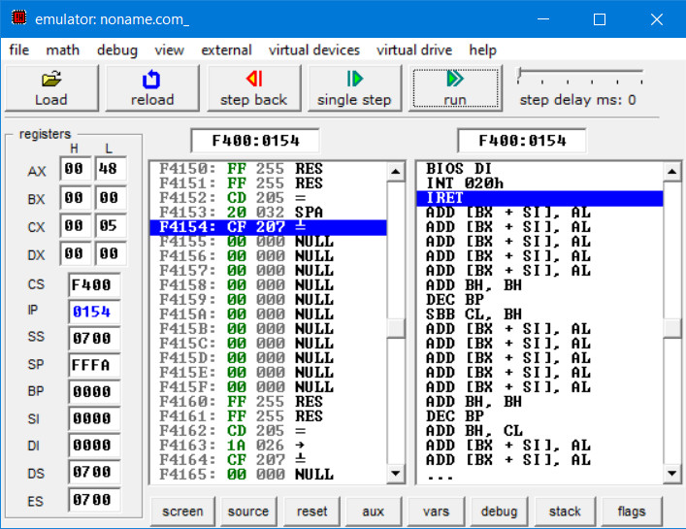

Exercise 1.3:

Code:
org 100h
MOV AL,00001111b
OR AL,61h
ret

Output:
AL = 6F or 01101111
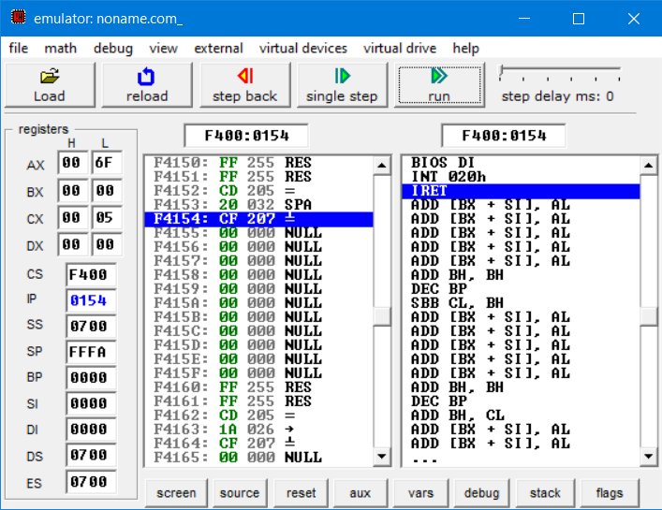

Exercise 1.4:

Code:
org 100h
MOV AL,94h
XOR AL,37h
ret

Output:
AL = 00
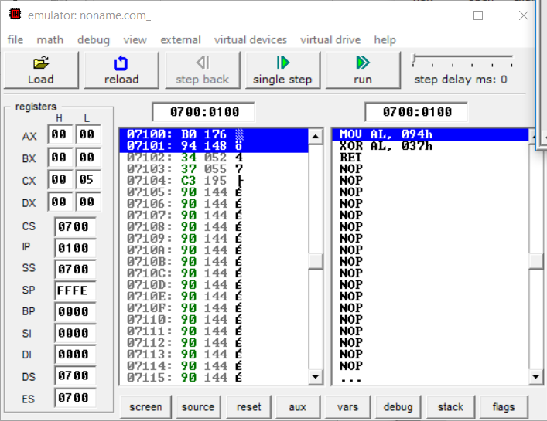

Exercise 2:

Code:
ORG 100h ; Starting point for COM file
MOV AX, 1234h ; Load AX with a 16-bit value
AND AX, 00FFh ; Clear the high 8 bits (AH), keep AL unchanged
; To verify the result, you can move AX to BX or any other register
MOV BX, AX
RET ; Return to DOS

Output:
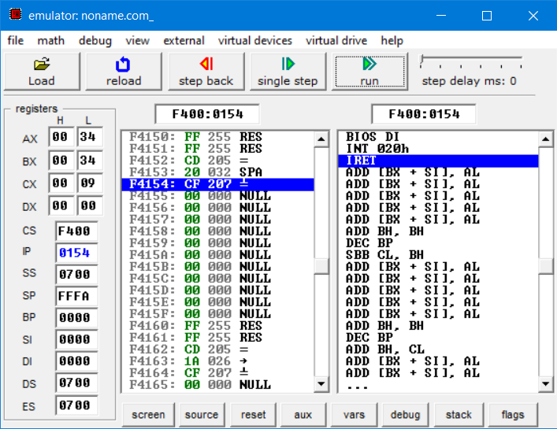

Exercise 3:

Code:
ORG 100h ; Starting point for COM file
MOV AX, 1234h ; Load AX with a 16-bit value
OR AX, 0FF00h ; Set the high 8 bits (AH), keep AL unchanged
; To verify the result, you can move AX to BX or any other register
MOV BX, AX
RET ; Return to DOS

Output:
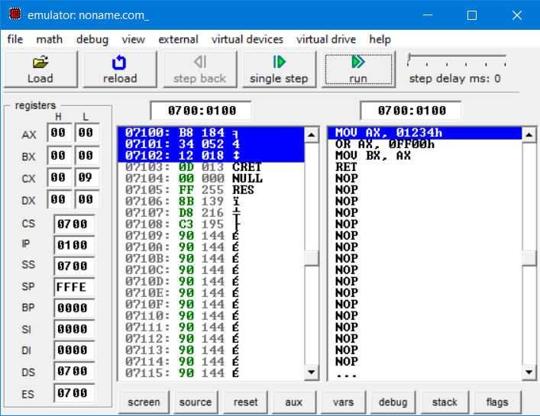

Exercise 4:

Code:
org 100h ; Origin address for the program
MOV AX, 1234h ; Load 16-bit value 1234h into AX (AX = 00010010 00110100b)
MOV BX, 5678h ; Load 16-bit value 5678h into BX (BX = 01010110 01111000b)
AND AX, BX ; Perform AND operation between AX and BX (AX = AX AND BX)
RET ; Return from program

Output:
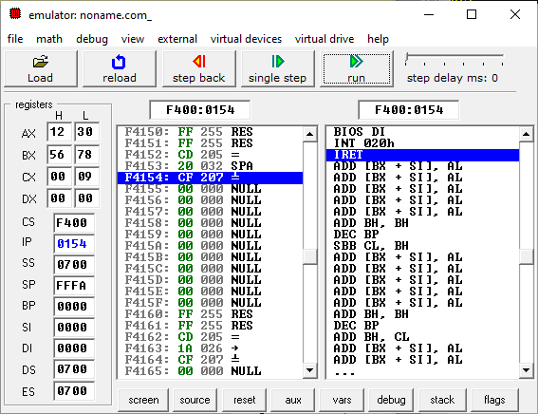

Exercise 5:

Code:
org 100h ; Origin address for the program
MOV AX, 1234h ; Load 16-bit value 1234h into AX (AX = 00010010 00110100b)
MOV BX, 5678h ; Load 16-bit value 5678h into BX (BX = 01010110 01111000b)
OR AX, BX ; Perform OR operation between AX and BX (AX = AX OR BX)
RET ; Return from program

Output:
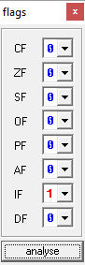

Exercise 6:

Code:
ORG 100h ; Starting point for COM file
MOV AX, 1234h ; Load first 16-bit value in AX
MOV BX, 5678h ; Load second 16-bit value in BX
XOR AX, BX ; Perform XOR operation between AX and BX
RET ; Return to DOS

Output:
